Matrix Inversion

Matrix inversion is one of the core part of the CoSaMP algorithm to estimate the target signal. In all the greedy algorithm matrix inversion of a full rank tall matrix is required. Inversion of the non-square matrix is executed by Moore-Penrose pseudoinverse denoted by Φ†. The major four-way to cope with matrix inversion are analytical, Cholesky factorization, modified Cholesky factorization, Chebyshev type method, LU, and QR decomposition methods.

**Moore-Penrose inverse**

Moore-Penrose inverse of a matrix φ ∈ Rmxn, denoted by Φ†, is a matrix X that satisfies the following four Moore-Penrose properties:









Where φ∗ is the conjugate transpose of φ.

If the above conditions are satisfied by matrix φ and its pseudo inverted matrix X = φ†, then Moore-Penrose inversion can be evaluated as





For a matrix φ ∈ Rmxn, if m=n then φ† = φ−1

**Modified Cholesky factorization method**

Modified Cholesky factorization method has advantages over other matrix inversion techniques as it does not require square-root operation. This method decomposed the given square matrix into a lower triangular and diagonal matrix. It can be formulated as equation



The lower triangular matrix F and diagonal matrix H are calculated using the following equations:

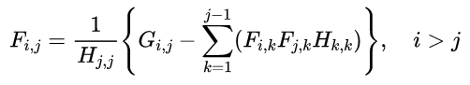

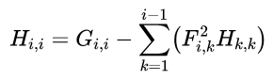

The inverse of matrix G computed by the following equation

